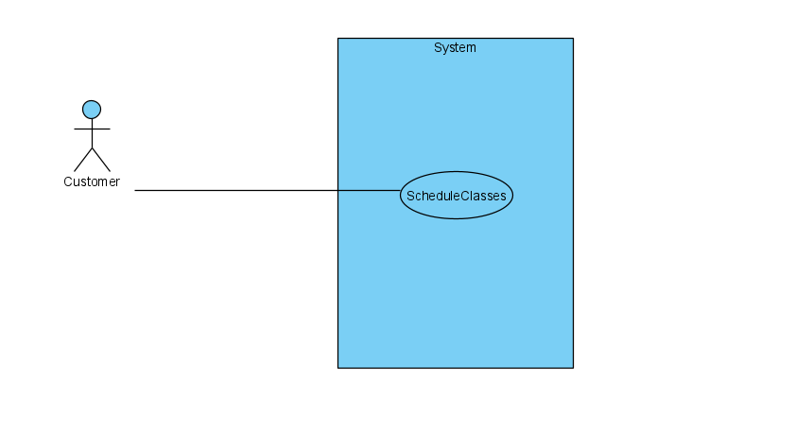

# Casual Use Case Specification: UC15

**Use Case Name: View Timetable**

**Brief Description:** this allows the memberships or customers to view their timetable with ProTKD Tae Kwon Do.

# Section 1: Business Rule(s):

BR 45: The customer must provide an existing personal information.

# Section 2: Scenarios (HD):

**Scenario 1: View Timetable**

# Preconditions: The customer must be able to sign in on the website.

| **Step#** | **Actor (**customer**)** | **System** | **Data Used** |
| --- | --- | --- | --- |
| 1 | Click on view timetable | Display the form input for the names and customer id | First name  Last name  Customer id |
| 2 | Enter first name, last name, and customer id. | Form data validation  First name must be entered   Last name must be entered   Customer id must be entered   Customer id must match in the database  Data is valid  Display the customer’s timetable | First name  Last name  Customer id |
| 3 | Repeat steps 1 to 2 until the user chooses to exit | Return to the homepage website |  |

**Successful Post-Conditions:** Customer’s timetable is displayed